Instructions

Objective: | Creating a visual representation of the necklace accompanied by a word cloud (or word map).
Activity:  Part 1  Visualization | Visualize what the necklace in the story looks like. Come up with a representation of the necklace. This representation may be literal or abstract.  You may:  - Draw what you think the necklace looks like;  - Find images on the internet to create a collage that represents your understanding of the necklace;  - Find an image on Google images that is close to how you imagine the necklace to appear, and then write a detailed description to accompany it (as though you were writing an advertisement for the necklace);  - Construct a three-dimensional, wearable necklace made from paper or other craft supplies; or  - Any other mode that relies on a visual representation.  Templates for most options are included in the assignment slides. Once you select an option, drag that slides to the top of the deck (make it Slide #1).  See:  - Add, delete & organize slides - Computer - Google Docs Editors Help  - Google Slides - Change Slide Order
Activity:  Part 2  Word Cloud | Once you’ve represented your vision of the necklace, create a word cloud (map) around your representation, made up of words or phrases that come to you when you look at your representation of the necklace.  Use one of the sites recommended below. For some of the sites, it works better if you copy and paste your list several times.  If your saved image file is in SVG format, you will need to convert it to PNG or JPG format before Google Slides will allow you to use it. You can convert the file format using this site: SVG to PNG
Submit | Make sure to attach all required documents to the assignment in Google Classroom before submission.  See:  - Attaching an existing file to an assignment in Google Classroom using a Laptop or Chromebook  - Upload images to Google Classroom Assignments from Cell Phone or Tablet  - Turn in an assignment - Android - Classroom Help
Digital Tools  (free, but registration may be required) | - Canva  - WordClouds.com  - Free Word Cloud Generator – MonkeyLearn  - Word Cloud Generator  - SVG to PNG

When you are putting together your word list or combining your lists of words, feel free to use the speech-to-text tool of your choice. That's what I did to write this.

I use Speechnotes.

Resource | How to Download Image | Example
WordClouds.com | 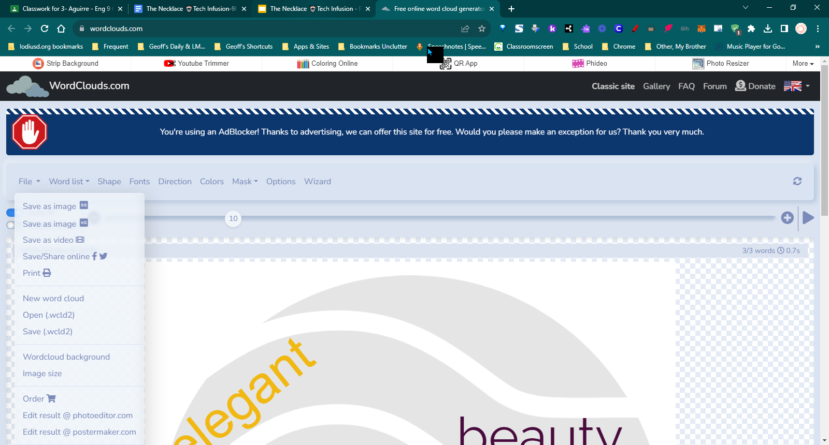 | 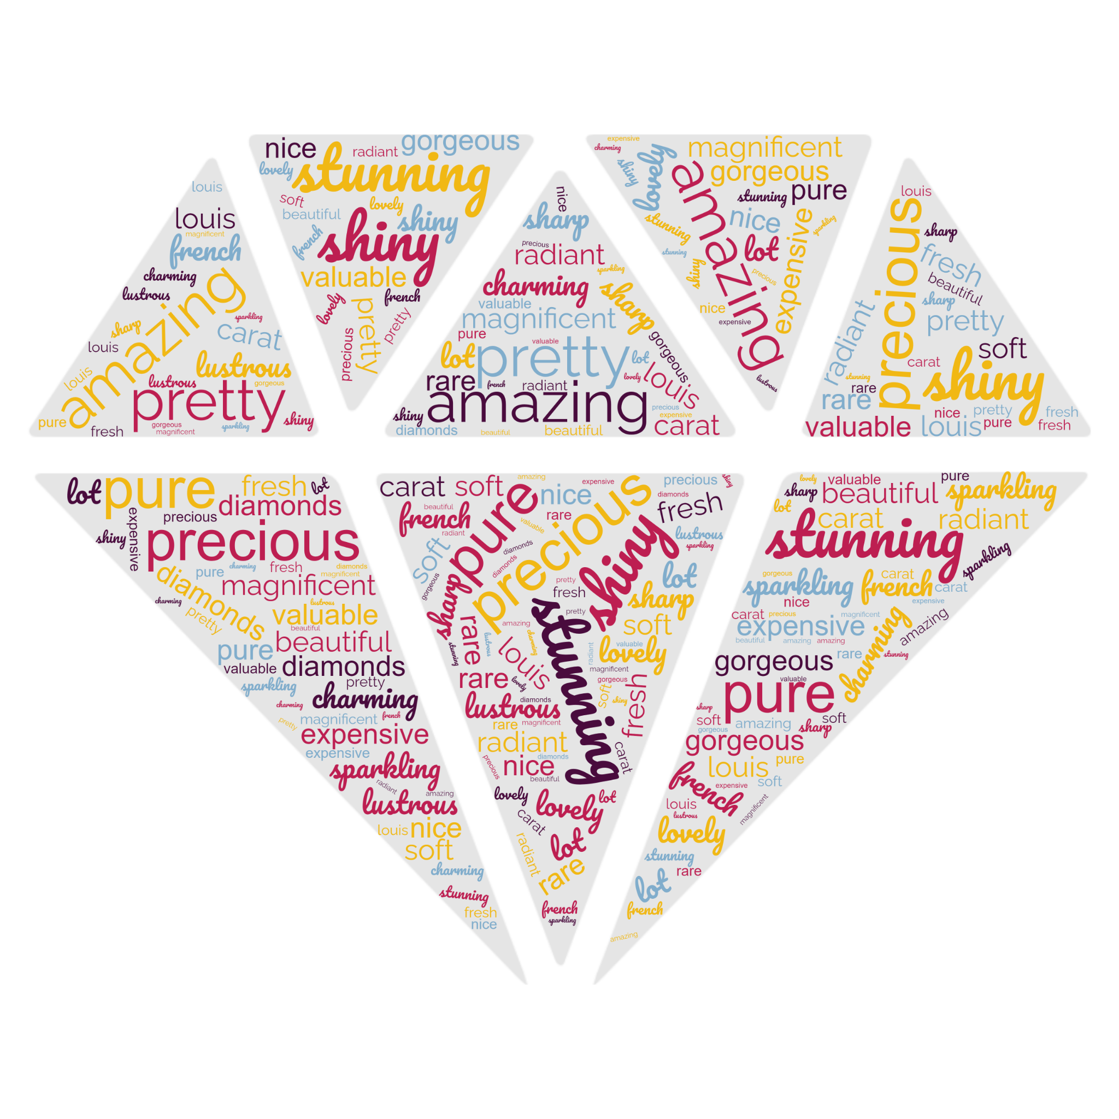
Free Word Cloud Generator – MonkeyLearn |  | 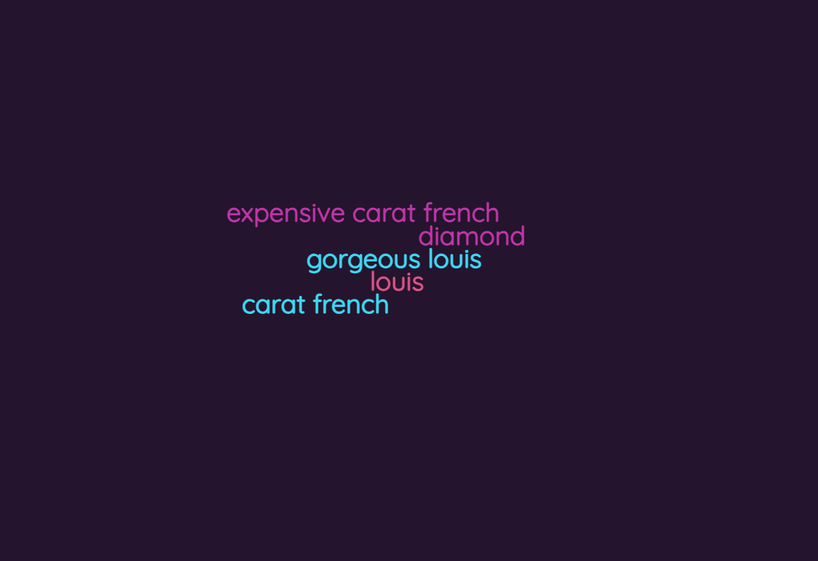
Word Cloud Generator | 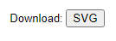 | 